Proyecto: Un Lugar Espectacular

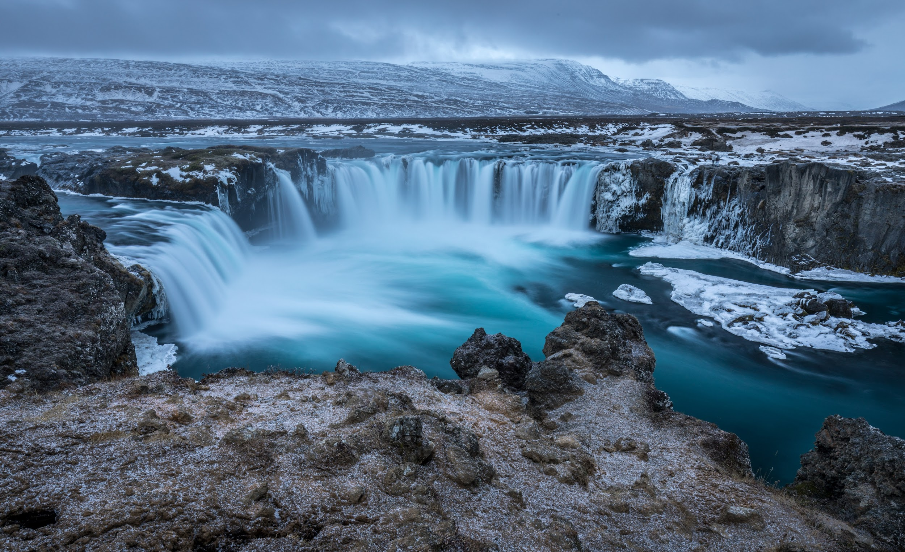

El nombre de mi destinación o festival:_El parque nacional el yunque, puerto rico _______________________________________

You will be choosing an exciting destination in a Spanish speaking country, perhaps during a particular celebration or tradition. Research the tourist attractions and popular activities there and then create your own Google Slides presentation to be shared with your classmates about an imaginary 4 day trip you are taking. You should only use the Present Tense to speak about this trip, and include a map and many pictures that show what the place looks like and has to offer tourists.

“El Yunque National Forest - Home: *USDA Forest Service”*

<https://www.fs.usda.gov/elyunque> Accessed:February 7, 2024

“El Yunque National Forest, Caribbean weather in December: average temperature & climate*: Wanderlog.”* <https://wanderlog.com/weather/81341/12/el-yunque-national-forest-weather-in-december>[/](https://theplanetd.com/puerto-rican-food/) Accessed: February 7, 2024

“El Yunque, Majestic Rocky Icon of Puerto Rico: Impervious to the Ravages of Time? *National Science”* Foundation <https://new.nsf.gov/news/el-yunque-majestic-rocky-icon-puerto-rico>[/](https://www.getyourguide.com/el-yunque-national-forest-l4730/activities-tc54/) Published: February 27, 2013 Accessed: February 8, 2024

“Diverse, Resilient and Unique: El Yunque National Forest: National Forest Foundation” <https://www.nationalforests.org/our-forests/light-and-seed-magazine/diverse-resilient-and-unique-el-yunque-national-forest> Accessed: February 8, 2024 Author: Geoff Gallice

“Major gold deposits discovered in Puerto Rico | WAR AGAINST ALL PUERTO RICANS: war against all puerto ricans” <https://waragainstallpuertoricans.com/2016/08/24/major-gold-deposits-discovered-in-puerto-rico/>[l](https://elyunque32196.weebly.com/fun-facts.html) Published: August 24, 2016 Accessed: February 8, 2024

“WordReference.com: English to French, Italian, German & Spanish Dictionary” <http://www.wordreference.com> Accessed: February 8, 2024

Requirements:

-Pictures on every slide of the presentation showing the destination/local people/traditional foods, and short video clips (in English ok)

-A map showing where in the world you are (country and city)

-Choose a time of year for your visit. Then mention a simple description of the weather (it is hot, it is cold, it is humid, it rains, it is sunny, etc.) for the time of year that you are there

-What typical dish(es) you eat in that region/country (name of the dish, and adjectives describing its main ingredients, flavors, and if you like it or not)

-Ordinal numbers to say what you do on the first, second, third, and fourth days

-10 different Present tense regular and irregular verbs (mention specifically your emotions, what activities you participate in, what you observe and say while there)

-10 descriptive adjectives to talk about what the place/people/food/sights are like, and local slang

-3 “fun facts” about the place or celebration *in English*

-5 multiple choice questions (all in Spanish) for your classmates to answer after your presentation

-A works cited page at the end of your presentation that includes MLA citations for every website, book, article, photo, video, etc. used to gather information/pictures (AVOID Wikipedia)

-Do NOT use translation websites in which you type in a block of text in English, translate it to Spanish and cut and paste it into your presentation. This will result in a referral to the Honor Council, as it is a violation of the honor code. To look up how to say a word you might not know, use [www.wordreference.com](http://www.wordreference.com).

Rubric: Un Lugar Espectacular

Nombre:

Nota: / 55 pts.

|  | above expectation &/or little to no grammar errors | meets expectation &/or few grammar errors | partially meets expectations &/or several grammar errors | below expectations &/or many grammar errors |
| --- | --- | --- | --- | --- |
| El lugar /5  what is this place/ what is the festival celebrating  What time of year are you there, and what is the weather like?  map (country and city) showing where the event or place is located |  |  |  |  |
| Descripción del lugar y comida /5  4-5 adjectives describing what the place/festival is like  include what the local people are like there (2-3 adjectives) and local slang  2-3 typical, authentic dishes/drinks eaten there, has the name of the dish, 3-4 main ingredients, describe the flavor and if you like it or not |  |  |  |  |
| Día 1 /5  includes the ordinal number 1st  has feelings/ emotions that match in gender and number with your gender  mentions the main things you see/hear/do/experience/learn/think that are unique to this place/festival  Día 2 /5  includes the ordinal number 2nd  has feelings/ emotions that match in gender and number with your gender  mentions the main things you see/hear/do/experience/learn/think that are unique to this place/festival |  |  |  |  |
| Día 3 /5  includes the ordinal number 3rd  has feelings/ emotions that match in gender and number with your gender  mentions the main things you see/hear/do/experience/learn/think that are unique to this place/festival |  |  |  |  |
| Día 4 /5  includes the ordinal number 4th  has feelings/ emotions that match in gender and number with your gender  mentions the main things you see/hear/do/experience/learn/think that are unique to this place/festival |  |  |  |  |
| Citas /5  include what you say while there, using quotation marks |  |  |  |  |
| 3 fun facts in English /5  quality photos/video(s) |  |  |  |  |
| 5 multiple choice questions /5 |  |  |  |  |
| MLA citations /5 |  |  |  |  |
| Audience participation sheet /5 |  |  |  |  |

In-class Participation Benchmarks

Day 1 goal:

-slides #1-4 (plus MLA citations on slide 16)

Day 2 goal:

-edits from day 1

-slides #5-8 (plus MLA citations on slide 16)

Day 3 goal:

-edits from day 2

-slides #11-13 (plus MLA citations on slide 16)

Day 4 goal:

-remaining edits

-copy/paste video(s) links here:

-multiple choice questions 1-5 **in Spanish**